Steps for extracting QFT library and Runnig QFT test in LISA

- extract this zip file under <amtak_home>/libraries
this will create a file structure: <amtak_home>/libraries/qftest/lib/ and
<amtak_home>/libraries/qftest/bin/
- Please follow the document for applying the lisa Extension (hook) for the QFTest. After extracting the qftest extension, the qftest extension should appear in the folder <AMTAK HOME>\extesnions\qftest\.
- Adding a QFT step in lisa.
  - In the new step dialog select TIBCO→QF-Test
  - 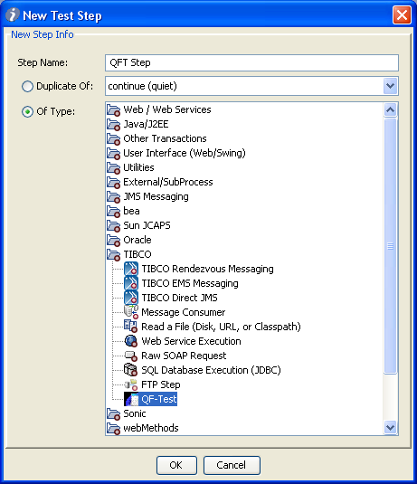
  - Provide the Field values
    - QF Test HOME:- path for the qft executable define by the Lisa property “QFTEST_HOME
    - Test File:-QFT test case file
    - Lib Path:- path for the QFT libraries
    - Runlog and report :- provide the path for report log directory.
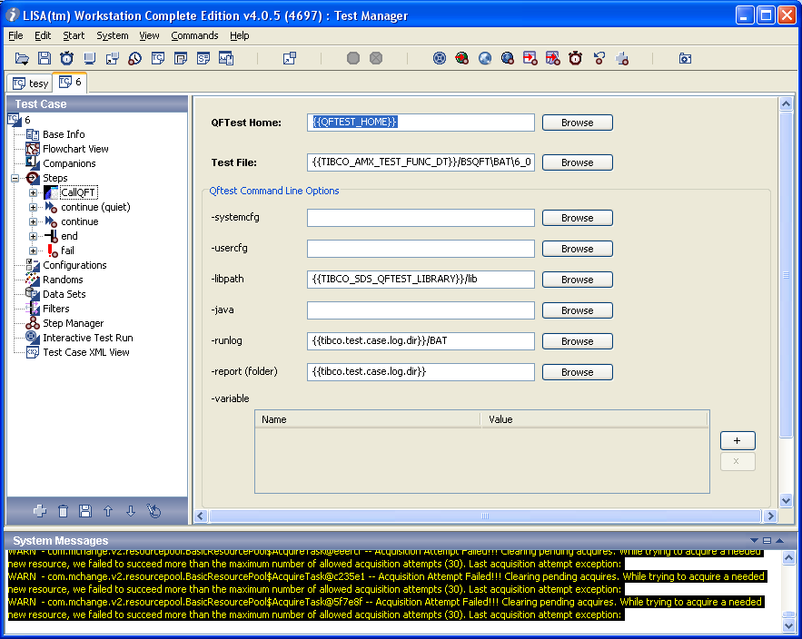
More details on these fields are available on the QFT extension help doc

